1. (薪資計算工具) 請發展一個C程式計算每位雇員的各類薪資所得。員工每週工作前40個小時內以「正常工資」計算薪資，超過40小時的部份則以，「正常工資的1.5倍」計算。
   1. 輸入值工作時數、每小時薪資。
   2. 輸出值為總薪資。

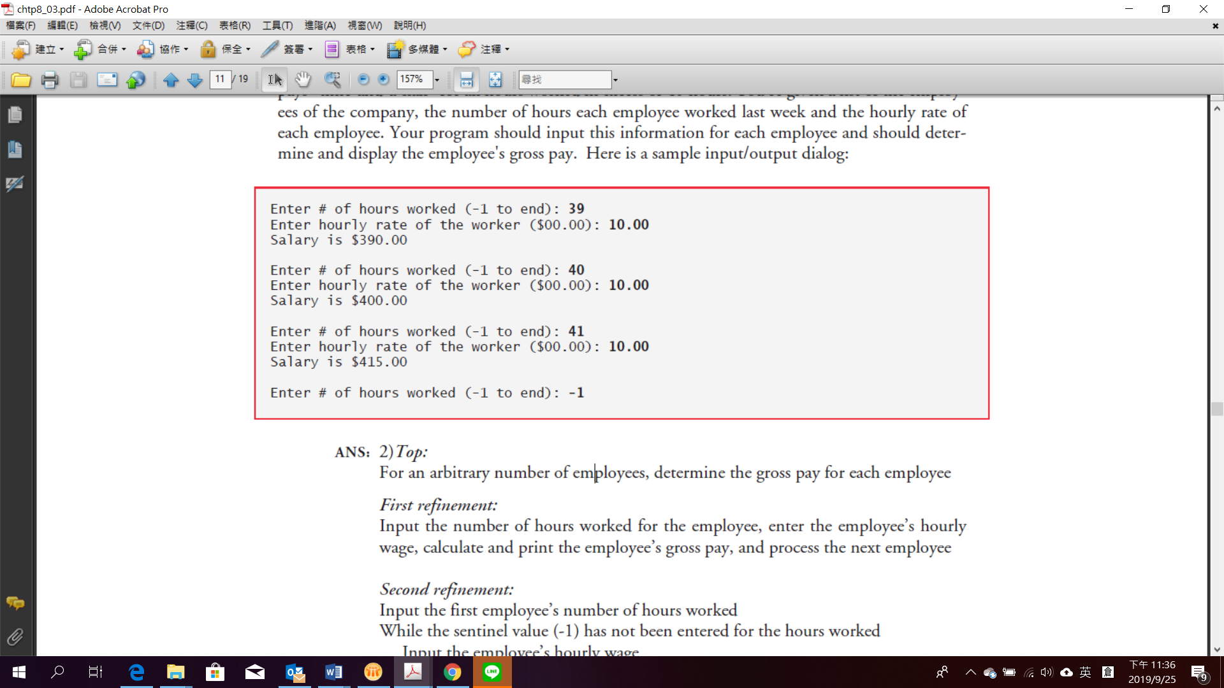

1. (找出最大數) 找出最大數(亦即在一堆數字中找出最大者)的程式在電腦應用上常被用到。舉例來說，一個判斷銷售人員贏得比賽。請撰寫一個C程式，連續輸入10個非負數值，然後判斷並印出最大者(提示: 程式碼應使用到下列三個變數)

Counter: 數到10的計數器。

Number: 目前輸入到程式的值。

Largest: 到目前為止，找到最大的值。

1. (檢查數字是否為質數) 質數是大於1的任何自然數，只能由1和數字本身整除。請編寫一個讀取整數並確定它是否為質數的C程式。
2. (阿姆斯壯數) 阿姆斯壯數是一個n位數，其各位數字的n次方和等於該數本身。例如，153等於13 + 53 + 33 。因此，153是一個阿姆斯壯數。請編寫程式來顯示所有三位阿姆斯壯數。
3. ***(Salary Calculator)*** Develop a program that will determine the gross pay for each of several employees. The company pays “straight time” for the first 40 hours worked by each employee and pays “time-and-a-half” for all hours worked in excess of 40 hours. You’re given a list of the employees of the company, the number of hours each employee worked last week and the hourly rate of each employee. Your program should input this information for each employee and should determine and display the employee's gross pay. Here is a sample input/output dialog:



1. ***(Find the Largest Number)*** The process of finding the largest number (i.e. the maximum of a group of numbers) is used frequently in computer application. For example, a program that determines the winner of a sales contest would input the number of units sold by each salesperson. The salesperson who sold the most units wins the contest. Write a C program that inputs a series of 10 number and determines and prints the largest of the numbers. [Hint: your program should use three variables as follows]:

Counter: A counter to count to 10 (i.e., to keep track of how many numbers have been input and to determine when all 10 numbers have been processed)

Number: The current number input to the program

Largest: The largest number found so far

1. ***(Checking if a Number is Prime)*** A prime number is any natural number greater than 1 that is divisible only by 1 and by itself. Write a C program that reads an integer and determines whether it is a prime number or not.
2. ***(Armstrong Numbers)*** Armstrong numbers are numbers that are equal to the sum of their dig-its raised to power of the number of digits in them. The number 153, for example, equals 13 + 53 + 33 . Thus it is an Armstrong number. Write a program to display all three-digit Armstrong numbers.